Evolution of cooperative personalities

By Joris Damhuis and Anna Wolters

Supervisor: Franjo Weissing

Main questions:

Do different cooperative personalities evolve to coexist in populations of different levels of responsiveness and signalling?

What are personalities? How are these observed in populations? 🡪 introduction

What is the consequence of cooperation in a population?

* Can cooperative personalities coexist with non-cooperative personalities? In what circumstances?

How does responsiveness influence the cooperation in a population?

Index:

Abstract

Introduction

* Elaborate on the questions
* Snowdrift game explanation

Model set -up

* Equations
* Model 0.0 and 0.1? plus data?

Introducing responsiveness (model 1.1/1.2/1.3)

* Why different models, what is the difference between the models? How can this be seen in the data?

Introducing signalling (model …)

Conclusion/discussion

* Further research possibilities 🡪 more cooperation games, metapopulations?

Abstract

Introduction

Recently empirical research suggest that animals show different personalities within a population, which is defined as different individual behaviour that is consistent over time (e.g. as a juvenile and as an adult) and context (e.g. in interaction with a predator and a potential mate).[1] This is not only true for animals, but is also found in birds, chimpanzees, fish, amphibians[2], spiders [3]and insects[4]. From an adaptive perspective an infinite plasticity of behaviour would be preferable, since an individual would have the right behaviour in any kind of situation. Than why is this not observed in the empirical data? Could some poorly understood evolutionary mechanism be at the core of this?

While aggressiveness and responsiveness have been subject to recent research, no models were created on cooperation in personalities. Deciding what to do based on the signal the partner in the interaction has given, is the core part of the model we implemented for the Snow Drift game. The snowdrift game can evolve to coexistence under the right circumstances, where a more broadly used prisoner’s dilemma focusses more on the free-riding problem. In the prisoner’s dilemma no cooperation is expected, since it is an evolutionary unstable strategy.[5]

In this research we aim at cooperation evolving as different personalities under different responsiveness and signalling levels. Do different cooperative personalities evolve to coexist in populations of different levels of responsiveness and signalling? First, the snowdrift game is implemented in several versions of the model described below. For the future, more aspects of cooperation can be looked into from different games like the prisoner’s dilemma and stag hunt.

*Snow drift game*

The pay-off matrix is shown below for benefits and costs as used in most of de models.

*Snowdrift Benefits = 4, costs = 2*

*Fitness graph of the snow drift game. Benefits = 4, costs = 2.*

Above shows the fitness graph of the snowdrift game. The benefits and the costs are the same as used in our model. On the x-axis the tendency to cooperate is given, where the y-axis shows the fitness. When the whole population defects (tendency to cooperate is zero) the best strategy to play is to cooperate. See also the pay-off matrix. The equilibrium will move to the right, until the equilibrium is reached at about 0.67. When the tendency to cooperate is 1 for the whole population, it would be better to defect. The chance is very high you’ll receive the benefits, without the costs. This would push the equilibrium to the left. An evolutionary stable strategy is predicted at around 2/3 (0.67) of the population.

*Histograms, possibilities for personalities in the population.*

Above shows different possibilities for reaching the equilibrium of around 0.67. All three possibilities can explain the equilibrium. Therefore, the standard deviation is used, to see what the variation in the population is. When the standard deviation is small, it is likely that the whole population has a cooperation tendency of 0.67 (possibility 3). When the standard deviation is large, it could be that the population either goes to one of the extremes (possibility 1) or an intermediate from (possibility 2).

Model set-up

***Payoff matrix***

*General Snowdrift Benefits = 4, costs = 2*

*Variation necessary for social responsiveness*

Payoff difference Δ between α and β (see general pay off matrix) is given by:

And:

For snowdrift pay-off matrix this is true:

Variation only comes about by mutation (rate = 0.01) in the first models. This should be large enough compared to the price of responsiveness in order for responsiveness to develop:

For example, in model 1.1 the found standard deviation is around 0.02, therefore the price should be smaller than 0.0012 in order to have a emerge of responsiveness.

Model 0.0 (no responsiveness)

*Small overview variables*

* B (benefits) 4
* C (costs) 2
* μ (mutation rate) 0.01
* P0 (cooperation either 0 or 1) 0.05, 0.95, 0.67
* nI (number of interactions) 10

*Model set-up/traits*

Each individual has nI interactions in its life and gets fitness according to payoff matrix depending on strategies. Next generation based on fitness values. μ chance to change P0 state.

*Data overview*

*Above shows the development of the mean fraction of cooperatives in a population of three population with different initial conditions. The blue point represents the population with 95% cooperatives, grey with 67% and orange with 5%.*

The figure shows that the population goes to the predicted ESS around 2/3 of the population being a co-operator. The slight oscillations around the equilibrium are due to the stochasticity of the model (mutations).

*Conclusion*

This model works as expected. As seen in the graph the

Model 0.1 (no responsiveness)

*Small overview variables*

* + B (benefits) 4
  + C (costs) 2
  + μ (mutation rate) 0.01
  + P0 (cooperation between 0 and 1) 0.05, 0.95, 0.67
  + nI (number of interactions) 10
  + σ (standard deviation of normal distribution used for change of P0) 0.01

*Model set-up/traits*

Everyone has nI interactions in its life. Gets fitness according to payoff matrix depending on strategies. Next generation based on fitness values. μ chance to change P0 by small amount taken from normal distribution with standard deviation σ).

*Data overview*

*Above shows the average P­­­0 of three populations. Blue represents the population where every individual has 95% tendency to cooperate with 0 variation. Orange is 5% cooperation, grey 67%.*

*The above shows the standard deviation of the average P0.*

The first figure shows the three different populations. The extreme values are considered to see if the equilibrium that is predicted is reached. The standard deviations show that the variation is relatively low, with some extreme outburst. This is probably due to stochasticity.

Introducing responsiveness

After setting up a basic model, responsiveness was introduced.

Model 1.1

|  |  |  |
| --- | --- | --- |
|  | Partner responsive | Partner unresponsive |
| Focal responsive | C = 1 -Pmean  D = Pmean | C = 1 – P0 (f)  D = P0 (f) |
| Focal unresponsive | C = P0 (f)  D = 1 – P0 (f) | C = P0 (f)  D = 1 – P0 (f) |

*Chances an individual does cooperate or defect. C = cooperate, D = defect, (f) = of focal individual.*

The above table is the core of the model.

*Small overview variables*

* + B (benefits) 4
  + C (costs) 2
  + μ (mutation rate) 0.01
  + P0 (cooperation between 0 and 1) 0.05, 0.95, 0.67
  + nI (number of interactions) 10
  + σ (standard deviation of normal distribution used for change of P0) 0.01
  + Pi (obtain information either 0 or 1) 0.5

*Model set-up/traits*

Everyone has nI interactions in its life. Gets fitness according to payoff matrix depending on strategies if no info is present. If info is present, individual guesses what partner will do depending on P0 if it’s not a responsive individual, otherwise based on mean cooperation chance in previous generation, and pick optimal strategy based on it. Next generation based on fitness values. μ chance to change P0 by small amount taken from normal distribution with standard deviation σ. μ chance to change Pi state.

*Data overview*

We had several problems with this model, below shows correctly what the chances are to cooperate and defect when in an environment with responsive and unresponsive individuals.

Focal = f, opponent = t, C = cooperate, D = defect.

|  |  |  |
| --- | --- | --- |
| Partner  Focal | Responsive | Unresponsive |
| Responsive | Cf = 1- Pmean  Df = Pmean  Cp = 1- Pmean  Dp = Pmean | Cf = 1 - P0(p)  Df = P0(p)  Cp = P0(p)  Dp = 1 - P0(p) |
| Unresponsive | Cf = P0(f)  Df = 1 – P0(f)  Cp = P0(f)  Dp = 1 - P0(f) | Cf = P0(f)  Df = 1 – P0(f)  Cp = 1 - P0(p)  Dp = P0(p) |

*Above, four scenarios in model 1.1 are laid out an individual can be responsive and unresponsive and can interact with a responsive and unresponsive individual. It shows the chances an individual who is responsive or not responsive will do cooperate or defect when interacting with a responsive or not responsive individual. Cf = chance focal individuals cooperate, Df­ = chance focal individual defects, Cp and Dp­ are the same but than for the partner. Pmean is the average strategy of the last generation, where P0 is the intrinsic.*

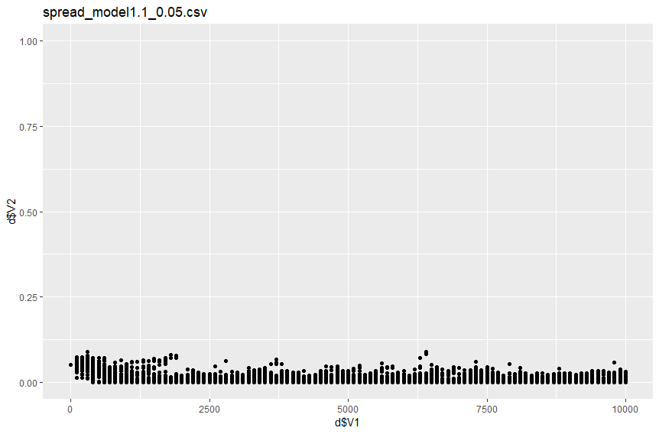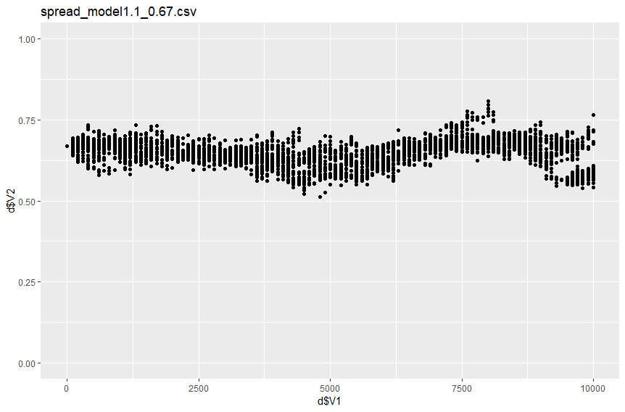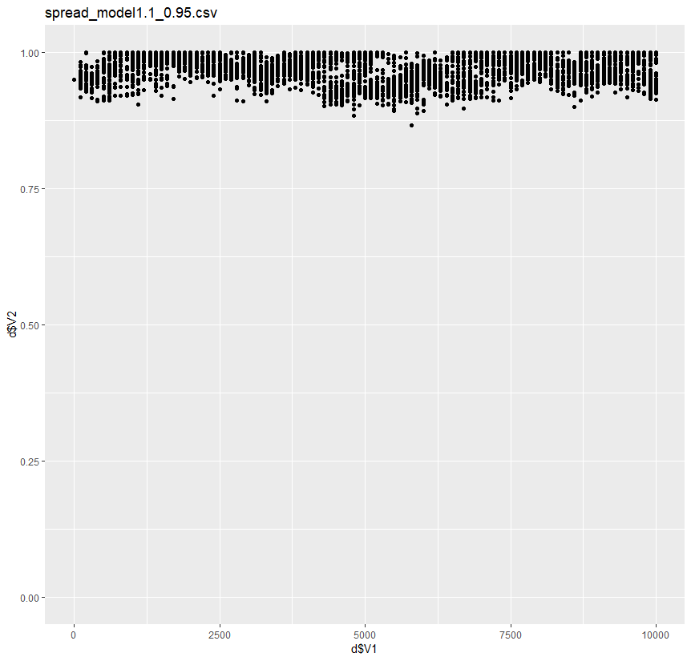

*Above the spread graphs of Model 1.1 are shown for three population with different initial conditions. For 10000 generations the tendency to cooperate of a thousand individuals are represented.*

The figures above show the

Model 1.2

*Small overview variables*

* + B (benefits) 4
  + C (costs) 2
  + μ (mutation rate) 0.01
  + P0 (cooperation between 0 and 1) 0.05, 0.95, 0.67
  + nI (number of interactions) 10
  + σ (standard deviation of normal distribution used for change of P0) 0.01
  + Pi (obtain information either 0 or 1) 0.5

*Model set-up/traits*

Everyone has nI interactions in its life. Gets fitness according to payoff matrix depending on strategies if no info is present. If info is present, individual guesses what partner will do depending on P0 if it’s not a responsive individual, otherwise based on mean cooperation chance in previous generation, and pick optimal strategy based on it. Next generation based on fitness values. μ chance to change P0 by small amount taken from normal distribution with standard deviation σ. μ chance to change Pi state.

Instead of immediate change in strategy in a responsive individual, a slighter chance to do cooperate when the other individual defects, is introduced.

*Overview of data*

*Above shows three replica populations with initial conditions of 100% responsive.*

When the standard deviation is above a certain level, unresponsiveness can be observed. The blue line shows higher variation due to stochasticity (mutation) and is therefore able to evolve into a total unresponsive population.

*Above shows the Pmean* *of the three replica populations described before with initial conditions of 67% cooperatives.*

These test show that it is possible under certain circumstances to invade an population of 100% responsive individuals.

*Above shows three populations with initially 0% responsive individuals. Very soon responsiveness is established in the population with small variation.*

*Above shows the P0  of three populations with different initial conditions. Very rapidly equilibrium is reached with relatively higher variation as seen before, with high peaks.*

*Above the P­mean is shown were the equilibrium is reached very quickly.*

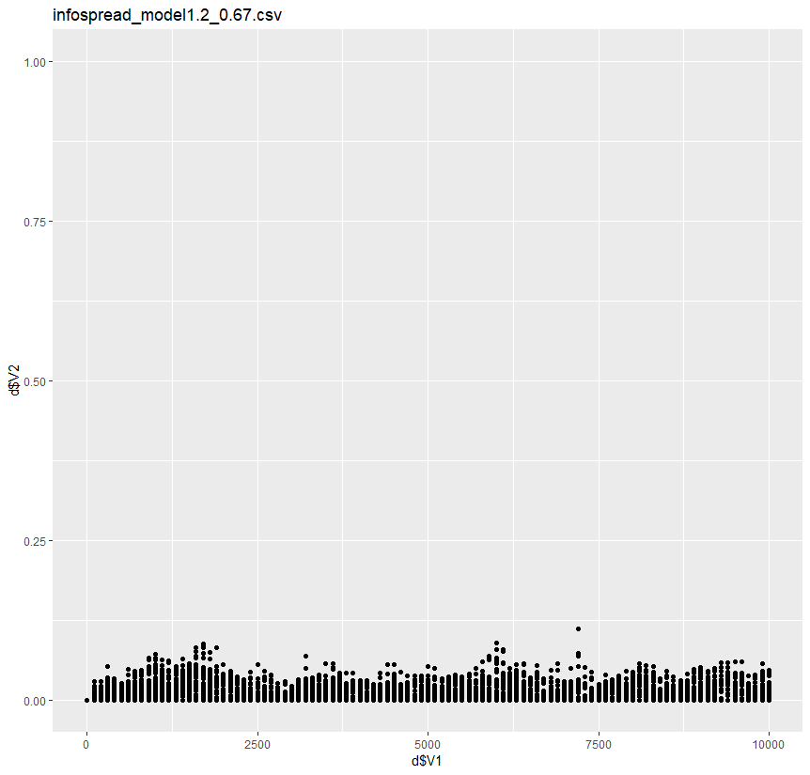

*Above data from model 1.2 is shown for the population that begins with 67% cooperatives and 0% responsiveness. Here the spread is shown for the responsiveness. It is very low and no clear distinctions in strategy are observed.*

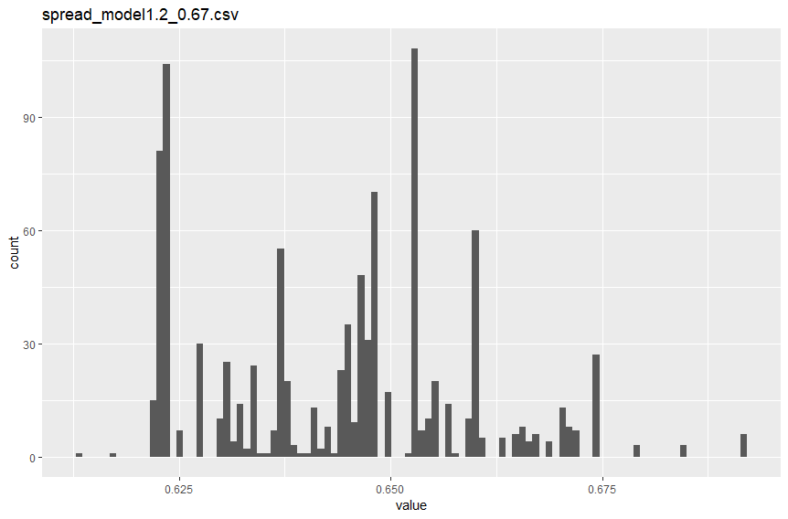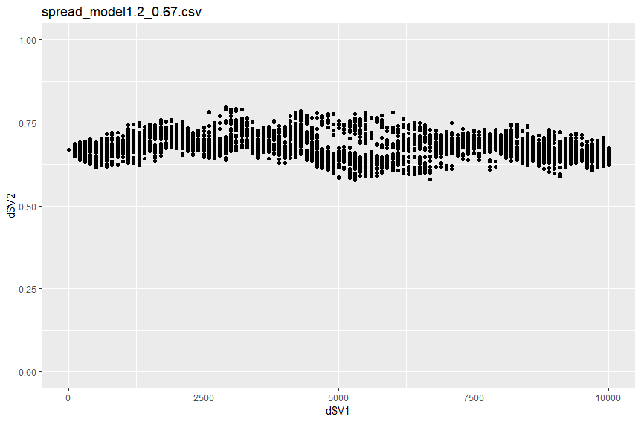

*Above the tendency to cooperate for model 1.2 is shown for the population with initial values of 67% cooperation.*

Interestingly, the spread graph shows a small divide in strategy around 5000 generations. Although this is hardly enough to say personalities are present. The histogram shows little variation in the last generation shown.

Model 1.3

*Overview of the variables*

*Model set-up*

Continues

*Data overview*

Introducing signalling

Conclusion and discussion

Possible extensions model/extra analysis

* Meta-populations
  + Randomly distribute the population into a community of size (between 20 and 100 or something). Than interactions only within community. Every generation, new randomly distributed meta-populations are defined. Unresponsive in population zero.
    - New meta-populations after every newly formed generation, because in our model no sexual reproduction is implemented.
  + Expectation: emerge of responsive individuals.
* Signalling implementation
* Is there a correlation between information tendency and the P0? *Ido Pen*

Feedback presentations

* 17-12-2018
  + Correlation P0 and information tendency?

*Franjo:* the coexistence of unresponsive and responsive is to be expected.

* + Make clearer graphs
    - Different graphs for every initial condition
    - Don’t call the models by the numbers we give them ourselves, but more like the different scenario’s
  + Why does the information tendency go to approximately 0.2 (or 0.1 in model 1.1 new) instead of dying out completely?
  + Did we test different costs and benefits?

Should this make a difference other than changing the equilibrium of the ESS?

It could be that the it would influence the tendency to ask information.

**Appendix**

Literature list

*Interesting not yet used literature:*

* Smaldino, P. E., Flamson, T. J. and McElreath, R. (2018) “The Evolution of Covert Signaling,” *Scientific Reports*, 8(1). doi: 10.1038/s41598-018-22926-1.

Extended data

Model 1.0

Focal individual does something based on what the opponent does based on his P0, even when the opponent is a responsive individual itself.

*Communication*

Only honest communication is evolutionary stable.[6]

*Small overview variables*

* + B (benefits) 4
  + C (costs) 2
  + μ (mutation rate) 0.01
  + P0 (cooperation between 0 and 1) 0.05, 0.95, 0.67
  + nI (number of interactions) 10
  + σ (standard deviation of normal distribution used for change of P0) 0.01
  + Pi (obtain information either 0 or 1) 0.5

*Model set-up/traits*

Everyone has nI interactions in its life. Gets fitness according to payoff matrix depending on strategies if no info is present. If info is present, individual guesses what partner will do depending on P0 and pick optimal strategy based on it. Next generation based on fitness values. μ chance to change P0 by small amount taken from normal distribution with standard deviation σ. μ chance to change Pi state.

*Data overview*

The responsiveness 50% at every population. Three different population with different initial conditions were tested (95%, 67% and 5% tendency to cooperate).

*The above shows the average tendency for every generations in the three different populations. All three populations started at the tendency to ask information of 50%. The tendency seems to go to equilibrium around 0.2. Therefore, the level of responsiveness is quiet low.*

*The above shows the P0 of the populations. All end up at the expected equilibrium of around 0.67. The 5% cooperatives take a long time to reach the equilibrium.*

*Above shows the Pmean of the generations of three different populations. Clearly the 5% cooperative population slowly goes to the equilibrium.*

Form the above three graphs, it is seen that responsiveness is not totally extinct, but stays on a level around 0.2. This is expected form the article of Wolf, van Doorn and Weissing. [7]

The second thing seen is that in a population were in the beginning only 5% starts with cooperation, the information tendency stays high for quit longer. In correlation with that the P0 stays low and the Pmean stays high for about the same amount of time.

*Problems with this model*

The responsive individuals in this model would base their next move on the P0 of the opponent instead of the Pmean. This would mean that the Pmean is not used at all and therefore no selection takes place.

Model 1.1 nul (control on Model 1.1)

*Small overview variables*

* + B (benefits) 4
  + C (costs) 2
  + μ (mutation rate) 0.01
  + P0 (cooperation between 0 and 1) 0.05, 0.95, 0.67
  + nI (number of interactions) 10
  + σ (standard deviation of normal distribution used for change of P0) 0.01
  + Pi (obtain information either 0 or 1) 0.5

*Model set-up/traits*

This is a control model to see if an equilibrium is found in the information tendency. Therefore, no selection is made for the next generation based upon fitness. Instead of a weighted lottery, a Gaushy distribution is used.

*Data overview*

*Above shows the information tendency. This will oscillate around 0.5.*

*Above shows the tendency to cooperate as an average over the whole population for three replica populations.*

*Above shows the P0 of three replica populations and its standard deviation. As can be seen, the populations have little variation. This is due to only small mutation rate.*

The P0 of the blue population shows a large difference. This is only due to the drift of the small mutation rates.

*Problems with this model*

The case that an unresponsive individual would run into a responsive individual would never be picked. This we saw when counts were introduced for every interaction between responsive and unresponsive individuals. The problem was that instead of looking at the strategy, we looked at the responsiveness, the P0, of the individuals to calculate the fitness. Which resulted in a case were the focal unresponsive individual interacting with a responsive individual would always both defects. Therefore, the total count of cooperation was off.

When introducing all kinds of extra counts into the model, the total amount of interactions was counted and the P0 and the Pmean­ were calculated. Here a discrepancy was observed between what the data showed and what was expected. We saw that the data made sense after fixing this.

1. Sih, A., Bell A., Johnson J. C. (2004) “Behavioral syndromes: an ecological and evolutionary overview.” *Trends in Ecology and Evolution*. **19**, 372 – 378
2. Gosling SD (2001) “From Mice to Men: What Can We Learn About Personality from Animal Research?” *Psychological bulletin*, 127(1), pp. 45–86.
3. Johnson J. C. & Sih A. 2005 precopulatory sexual cannibalism in fishing spiders (*Dolomedes triton*): a role for behavioural syndromes. *Behav. Ecol. Sociobiol.* **58**, 390 – 396
4. Brodin, T. and Johansson, F. (2004) “Conflicting Selection Pressures on the Growth/predation-Risk Trade-Off in a Damselfly,” *Ecology*, **85**, pp. 2927–2932. doi: 10.1890/03-3120.
5. VOETNOOT NOG INVOEGEN
6. Botero, C. A., Pen, I., Komdeur, J., Weissing, F. J. and Doebeli, M. (2010) “The Evolution of Individual Variation in Communication Strategies,” *Evolution*, 64(11), pp. 3123–3133.
7. Wolf M., Van Doorn G. S. & Weissing F.J. 2010 On the coevolution of social responsiveness and behavioural consistency. *Proc. R. Soc. B*. **278,** 440 – 448

   